Smart Nexus Systems for Water-Energy-Food-Ecosystems Efficiency: Machine Learning-Based Early Warning for the Litani Basin, Lebanon
Ali Karnib¹, Charbel Khabbaz¹, Mouaz Amoud¹, Mohamad Mehdi¹, Fadila Al Omar¹
¹Department of Liberal Arts and Sciences, Lebanese American University, Beirut, Lebanon
KEYWORDS |  | ABSTRACT
WEFE Nexus  Litani River Basin  Machine Learning  NDVI  NDTI  VIIRS  Early Warning System  Remote Sensing  Sustainable Development Goals |  | The Litani River Basin is experiencing intensifying multi-sector stress across the Water–Energy–Food–Ecosystem (WEFE) nexus, yet municipalities lack an operational early-warning tool capable of detecting simultaneous environmental pressures. This study develops a municipal-scale WEFE Stress Index and machine-learning early-warning framework using daily satellite observations from 2014–2025. Four indicators, NDVI, NDTI, rainfall, and VIIRS night-time radiance, were extracted via Google Earth Engine and normalized using percentile-based scaling with stress-direction alignment. The composite index follows a transparent structure in which each WEFE pillar contributes equally, with minimal randomized weight perturbation to enhance model generalization while preserving interpretability. Two predictive models, Linear Regression and Random Forest, were trained to reproduce and forecast the index. Evaluation using temporally independent test sets and 5-fold cross-validation showed high accuracy (R² = 0.94–0.98; RMSE = 0.0096–0.0153). Both models consistently identified NDTI as the primary driver of stress, underscoring the influence of turbidity and ecosystem degradation. The index captured seasonal cycles and reproduced known drought peaks, including the 2020–2021 crisis. The resulting Green–Amber–Red alerts provide an operational decision-support tool for irrigation scheduling, water allocation, and ecosystem protection. The study’s methodological contribution lies in integrating multi-sector satellite indicators with interpretable machine-learning models to produce a scalable WEFE early-warning system for data-limited environments such as Lebanon.

Introduction
The Litani River Basin, Lebanon’s largest watershed, is undergoing simultaneous stress across water, energy, food, and ecosystems (WEFE). Recent drought episodes, most notably the record-breaking 2025 event during which Lake Qaraoun reached unprecedented lows, have amplified electricity shortages, disrupted irrigation cycles, and exposed degraded aquatic ecosystems (Reuters, 2025; Ministry of Energy and Water, 2020; FAO, 2025). These conditions reflect long-standing structural pressures driven by climate variability, pollution, and institutional fragmentation, all of which limit the capacity for coordinated basin management. Lebanon’s Updated National Water Sector Strategy (2020–2035) calls for integrated, cross-sectoral monitoring aligned with SDGs 2, 6, 7, 13, and 15 (Ministry of Energy and Water, 2020). However, municipalities in the Litani currently lack a composite early-warning tool capable of detecting concurrent stress, such as rainfall deficits, declining vegetation, falling night-time radiance, or rising water turbidity, before impacts intensify. Advances in Earth observation and machine learning now enable continuous monitoring of these signals using precipitation anomalies, NDVI, NDTI, and VIIRS night-lights (Agarkova, 2025; NASA Earthdata, n.d.; Carlowicz, 2017). Addressing the absence of a municipal-scale WEFE index is therefore an essential step toward operational early warning.

Existing approaches
International literature has progressed from conceptual “nexus thinking” to quantitative composite indicators that integrate multi-sector data (Simpson & Jewitt, 2019; He et al., 2024). The WEF Nexus Index exemplifies this evolution, providing country-level assessments derived from multiple indicators and structured according to established JRC principles for transparency and robustness (European Commission, Joint Research Centre, 2018; Simpson et al., 2022). Context-specific adaptations demonstrate the value of downscaling. Mexico’s state-level WEF Security Index incorporates socio-economic and resource variables to detect pre- and post-pandemic changes (Raya-Tapia et al., 2023), while a sub-state index in Alaska highlights spatial disparities in water access, energy affordability, and food distribution (Smith Lopez et al., 2024). Across these cases, Earth observation plays an increasingly central role, satellite rainfall, NDVI, and night-time lights expand spatial coverage and temporal frequency, strengthening the evidence base for multi-sector assessment (Agarkova, 2025; NASA Earthdata, n.d.).

Comparative summary
Across existing indices, three themes consistently emerge. Scale: While global and national indicators support benchmarking, they often mask local variability; sub-national tools recover granular patterns relevant for municipal action (Raya-Tapia et al., 2023; Smith Lopez et al., 2024). Indicator composition: Traditional statistics are now frequently complemented by remote-sensing proxies, precipitation anomalies, vegetation indices, and night-lights, providing timely and spatially detailed insights (Carlowicz, 2017; NASA Earthdata, n.d.). Functionality: Many indices describe current conditions; far fewer integrate predictive modeling or early-warning capabilities (He et al., 2024). Together, these findings point to the need for a downscaled, predictive WEFE index tailored to specific basins such as the Litani.

Persistent methodological gaps
Despite global advancements, significant gaps remain for Lebanon: Absence of a municipal WEFE early-warning index: National assessments remain siloed and not integrated across sectors (Ministry of Energy and Water, 2020). Limited representation of ecosystems ("E"): Ecological conditions are often implicit despite clear degradation in the Litani (FAO, 2025). Fragmented datasets: Rainfall, vegetation, power availability, and water quality are monitored using different systems, complicating unified analysis. Moreover, Lebanese research has yet to fully integrate satellite-based data for real-time monitoring, which limits the ability to capture spatially detailed and timely environmental dynamics. Lack of predictive modeling. Existing indices rarely use historical stress episodes to detect precursors (He et al., 2024). Limited operational early warning. Basin-scale drought early-warning tools exist but are not integrated across sectors (El Tayara, 2023; Reuters, 2025). These gaps leave municipalities reactive and unable to anticipate cross-sector crises.

Toward a municipal WEFE early-warning index for the Litani
This study advances a transparent, remotely sensed WEFE Stress Index designed for municipal decision support in the Litani Basin. The approach integrates four satellite-based indicators, rainfall (Water), VIIRS night-time radiance (Energy), NDVI (Food/vegetation), and NDTI (Ecosystems/water quality), into a unified framework using Google Earth Engine (Agarkova, 2025; Digital Earth Africa, n.d.; NASA Earthdata, n.d.). These data streams provide continuous, spatially consistent monitoring of WEFE dynamics across the Litani Basin without the need for additional local observations.
The index standardizes all indicators to a common scale and applies a machine-learning model to detect multi-signal stress patterns indicative of emerging crises. Outputs include continuous stress scores and Green/Amber/Red alerts to support early action by municipalities.

Research contribution
This study advances a Litani-specific approach to integrated WEFE assessment and early warning by delivering:
The first municipal-scale WEFE Stress Index for the Litani Basin, incorporating water, energy, food, and ecosystem pillars into a single operational measure aligned with national strategy goals (Ministry of Energy and Water, 2020; FAO, 2025). Remote-sensing data integration: Satellite-derived indicators, rainfall, NDVI, VIIRS night-lights, and NDTI, combine to offer continuous, high-resolution monitoring, addressing gaps in traditional datasets and enabling real-time, basin-wide tracking (Agarkova, 2025; Digital Earth Africa, n.d.; NASA Earthdata, n.d.; Carlowicz, 2017). Transparent composite design: Indicator selection and equal weighting are documented, following JRC guidelines for composite indices to ensure methodological clarity and stakeholder confidence (European Commission, Joint Research Centre, 2018; Simpson et al., 2022). Predictive machine-learning alerts: The model detects multi-signal precursors to emerging WEFE stress, moving beyond retrospective analysis to forecast potential crises and generate actionable, thresholded warnings (He et al., 2024; Agarkova, 2025). Actionable decision support: Outputs, including Green/Amber/Red alerts, provide municipalities with practical tools for managing resource allocation, such as scheduling water trucking, coordinating irrigation, and protecting ecosystems ahead of peak stress.
Together, these contributions operationalize the WEFE nexus for the Litani, empowering municipalities to proactively manage interconnected environmental risks rather than reacting to crises after they peak.

Research question
The primary research question addressed by this study is:
How can a composite WEFE Stress Index be constructed and integrated with machine learning models to evaluate and forecast water, energy, food, and ecosystem stress in the Litani Basin?
This question guides the development of a municipal-scale, data-driven index designed to assess and predict the compound stresses within the Water–Energy–Food–Ecosystem (WEFE) nexus. By integrating Earth observation data and machine learning, the study aims to provide actionable insights for municipalities in the Litani Basin, enabling proactive decision-making.

Methods

Feature Distribution and Index Structure
This study constructs a composite WEFE (Water-Energy-Food-Ecosystem) Stress Index inspired by the WEFE Nexus Index and the JRC-COIN framework for composite indicators. The index consists of four equally weighted pillars, Food, Water, Energy, and Ecosystem, reflecting both resource availability and household access. Each pillar contributes equally to preserve the system’s multi-centric nature:
$$WEFE Index= \frac{\left(P_{food}+ P_{energy}+P_{water}+P_{ecosystem}\right)}{4}$$
Table 1: Pillars, Indicators, and Stress Alignment for the WEFE Stress Index
Pillar | Indicator | Stress Alignment
Food | NDVI(Normalized Difference Vegetation Index) | Inverted: high NDVI low stress
Water | Rainfall | Inverted: high rainfall low stress
Energy | VIIRS Surface Reflectance Proxy | Inverted: high VIIRS low stress
Ecosystem | NDTI (Normalized Difference Turbidity Index) | Direct: high turbidity high stress
Each WEFE pillar is initially assigned an equal weight of 0.25 to reflect the multi-centric nature of the system. Due to the absence of independent observational data for WEFE stress, the index itself serves as the target for model training. To enhance numerical stability and prevent undue influence from extreme values or deterministic weight assignments, a minimal randomized adjustment of ±0.1% is applied to the weights for each observation, followed by re-normalization so that the weights sum to one. This slight perturbation allows the model to generalize the underlying formula rather than memorize fixed weights and does not materially affect the computed index.
Robustness Assessment: A systematic sensitivity analysis was performed by varying pillar weights by ±10%. The resulting changes in the final WEFE Stress Index were less than 5%, confirming that the index is robust to reasonable weight variations and that the randomized adjustment preserves both interpretability and methodological integrity. This approach ensures that the model can effectively learn the structure of the composite index while maintaining transparency and reproducibility.

Data Collection
Daily environmental data for the Litani Basin (2014–present) were obtained using the Google Earth Engine (GEE), providing high-resolution satellite and climate datasets. Four indicators corresponding to the WEFE pillars were collected:
- Food (NDVI): Derived from MODIS surface reflectance (MOD09GA) using Near-Infrared (Band 2) and Red (Band 1) bands. NDVI captures vegetation health and productivity.
- Ecosystem (NDTI): Calculated from MODIS Red and Blue bands to quantify water turbidity and ecosystem stress.
- Water (Rainfall): Daily precipitation sums obtained from the CHIRPS dataset to represent water availability.
- Energy Proxy (VIIRS): MODIS NIR Band 2 used as a proxy for daily VIIRS M7 observations, capturing surface reflectance variations related to energy and ecosystem dynamics.
Data were filtered to the Litani Basin boundary and aggregated at the daily scale. Pixel-level values were averaged to generate a single daily observation per indicator. Missing values were imputed using column means to maintain a complete time series.
This approach provided long-term, high-resolution daily datasets suitable for constructing the WEFE Stress Index and training predictive models. Automated GEE processing ensured reproducibility and consistency across spatial and temporal scales.

Data Preprocessing and Normalization
$$X^{'}=\frac{X - X_{min}}{X_{max}- X_{min}}$$
To standardize features and minimize the effect of outliers, a robust Min–Max normalization was applied:
- Percentile-Based Bounds: The 1st percentile defined the lower bound, and the 99th percentile defined the upper bound. Values outside this range were clamped to prevent anomalies.
- 10× Outlier Rule: If the maximum value exceeded ten times the second-largest value, it was capped to the second-largest value to prevent extreme outliers from skewing normalization and to prevent anomalies.
- Stress Direction Alignment: Features where higher values indicate lower stress (NDVI, Rainfall, VIIRS) were inverted (1 − X), while NDTI remained direct.
Normalized features were combined with the slight randomized weight adjustment (±0.1%) described in Section 2.1 to compute the final WEFE Stress Index.
Stress levels were classified for interpretability:
- 0 – 0.3 (Green): Low stress
- 0.3 – 0.7 (Amber): Moderate stress
- >0.7 (Red): High stress

Model Development
Two predictive models were implemented to map the four normalized indicators to the WEFE Stress Index:
Linear Regression Model:
A linear regression model was implemented to estimate the contributions of each indicator while preserving interpretability for decision-makers:
$WEFE Stress Index= β_{0}+ β_{1}NDVI+β_{2}NDTI+ β_{3}Rainfall+β_{4}VIIRS+ ε$
β₀: Intercept, representing baseline stress when all predictors are zero.
β₁–β₄: Coefficients, quantifying each indicator’s contribution to the stress index.
ε: Residual error capturing unexplained variability.
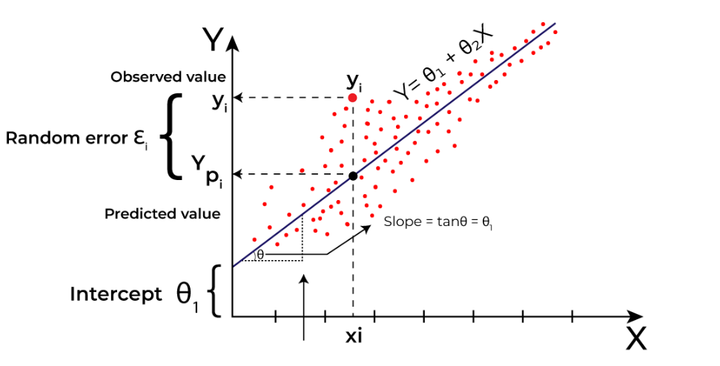
Figure 1: Linear regression model
A two-stage validation approach was planned to ensure model generalization:
- Hold-out Test Set: Performance evaluated on a temporally independent dataset to ensure generalization.
- Cross-Validation: 5-fold cross-validation applied across the full dataset to assess stability and robustness.

Random Forest Ensemble Model (Non-Linear Benchmark Model)
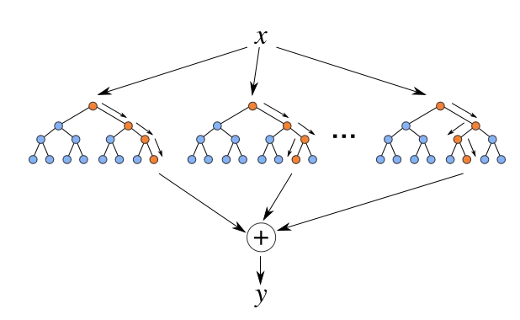
Figure 2: Random Forest model
A Random Forest model was implemented as a nonlinear benchmark to capture potential interactions among WEFE indicators. The ensemble constructs multiple decision trees using bootstrapped samples and random feature selection. Hyperparameters were kept at default settings to avoid overfitting and maintain comparability with the linear model.
Both models were trained using the same input features and the WEFE Stress Index target. Performance was evaluated using standard metrics (R², RMSE), and feature importance analysis was planned to interpret predictor contributions.

Model Validation and Comparison
To assess the suitability of each modeling approach, the following strategies were applied:
- Hold-out Test Set: Performance evaluated on a temporally independent dataset to ensure generalization.
- Cross-Validation: k-fold cross-validation is used to evaluate model stability across different data partitions, where k=5.
- Comparative Assessment: Linear Regression provided a transparent, interpretable baseline, while Random Forest was used to explore potential nonlinear effects and complex interactions among indicators.
- Interpretability Measures: For Random Forest, feature importance analysis was planned to identify the relative contributions of each WEFE pillar to predicted stress.
Model Comparison:
While Linear Regression provides transparency and interpretability, the Random Forest model demonstrates higher predictive accuracy by capturing nonlinear interactions among the WEFE pillars. Both models show robust performance, but the Random Forest serves as a nonlinear benchmark for precision, whereas the linear model offers a clear baseline for understanding variable contributions to system stress.

Data Visualization and Validation
Data visualization was employed both for exploratory analysis and validation of the preprocessed datasets. Exploratory visualization helped identify seasonal cycles, anomalies, and inter-variable relationships across NDVI, NDTI, rainfall, and VIIRS indicators prior to model training. Rolling 30-day means were plotted to reveal vegetation responses to rainfall deficits, turbidity spikes following precipitation events, and surface reflectance variations associated with land dryness.
From a validation standpoint, visualization ensured that normalization and stress alignment preserved the expected environmental relationships. Overlay plots confirmed inverse correlations between rainfall and WEFE stress, and co-occurrence between vegetation decline (low NDVI) and high turbidity (NDTI). This step verified the internal consistency and physical plausibility of the datasets before index modeling.
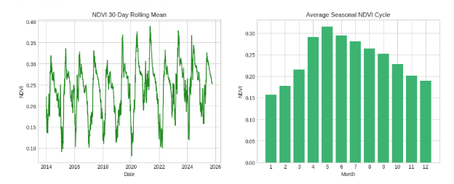
Figure 2: NDVI trend variation
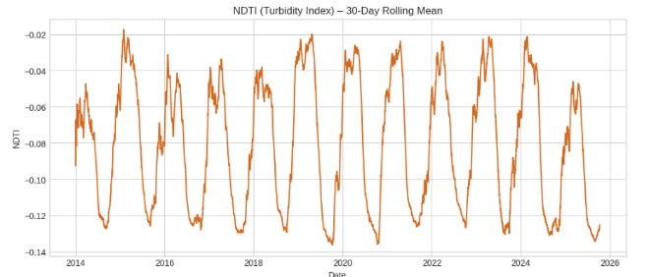
The left panel displays the NDVI (Normalized Difference Vegetation Index) 30-day rolling mean, showing consistent seasonal vegetation dynamics with annual peaks during wet seasons and troughs in dry periods. The right panel aggregates this data to depict the average seasonal NDVI cycle, showing maximum vegetation greenness between April and June, followed by gradual declines toward the dry season. This pattern aligns with the rainfall-driven growth cycle observed regionally.
Figure 3: NDTI trend variation
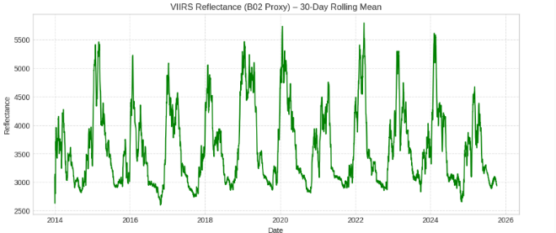
The Normalized Difference Turbidity Index (NDTI) reflects changes in water turbidity and sediment concentration. Lower (more negative) NDTI values suggest clearer water, while higher values indicate increased turbidity. The cyclic pattern mirrors hydrological cycles, with turbidity spikes typically following rainfall events due to runoff and sediment input.
Figure 4: VIIRS trend variation
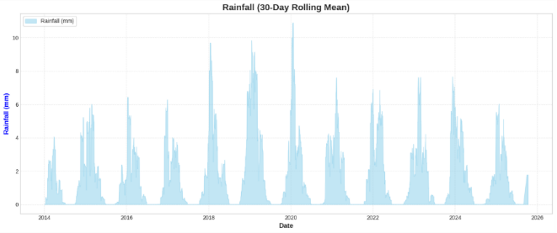
This plot presents the VIIRS satellite reflectance (B02 band), which acts as a proxy for surface and vegetation conditions. Reflectance peaks align with periods of lower vegetation cover or dryness, while troughs indicate higher greenness or moisture presence. The cyclical pattern reinforces seasonal reflectance variability linked to vegetation and surface water dynamics.
Figure 5: Rainfall trend variation
This graph shows the temporal variation in rainfall (in millimeters), smoothed using a 30-day rolling mean to highlight seasonal and interannual patterns. Peaks correspond to the wettest periods of each year, while the troughs indicate dry seasons. The cyclical nature of rainfall reflects the region’s distinct wet and dry climatic phases, providing a baseline for understanding hydrological variability over time.

Results

Model Performance
Both Linear Regression and Random Forest Regression were trained to predict the WEFE Stress Index using NDVI, NDTI, rainfall, and VIIRS proxy as input features. The Linear Regression model achieved a test-set R² of 0.9479 and an RMSE of 0.0153. Its 5-fold cross-validation results produced an average R² of 0.9603 and an average RMSE of 0.0137. The model’s coefficients were 1.583673 for NDTI, −0.522811 for NDVI, −0.004804 for rainfall, and −0.000039 for the VIIRS proxy.
The Random Forest model achieved a higher predictive performance, with a test-set R² of 0.9796 and an RMSE of 0.0096. The 5-fold cross-validation yielded a mean R² of 0.9793 and a mean RMSE of 0.0100. The model’s feature importance ranking showed NDTI as the most influential variable (0.571575), followed by NDVI (0.185250), rainfall (0.180721), and the VIIRS proxy (0.062455).
Table 2: Performance Metrics of Predictive Models
Metric | Linear Regression | Random Forest
Test R² | 0.9479 | 0.9796
Test RMSE | 0.0153 | 0.0096
5-Fold CV Mean R² | 0.9603 | 0.9793
5-Fold CV Mean RMSE | 0.0137 | 0.0100

Model Feature Contributions
The Linear Regression model produced coefficients of 1.583673 (NDTI), −0.522811 (NDVI), −0.004804 (rainfall), and −0.000039 (VIIRS proxy). The Random Forest model ranked the features by importance as follows: NDTI (0.571575), NDVI (0.185250), rainfall (0.180721), and VIIRS proxy (0.062455).
Table 3: Predictor contributions to the WEFE Stress Index from Linear Regression and Random Forest.
Feature | Linear Regression Coefficient | Random Forest Importance
NDTI | 0.9479 | 0.9796
NDVI | 0.0153 | 0.0096
Rainfall | 0.9603 | 0.9793
VIIRS | 0.0137 | 0.0100

WEFE Stress Index Behavior
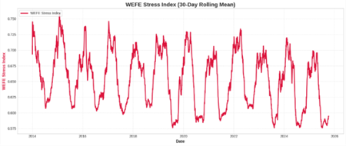
The WEFE Stress Index reflected a continuous and repeating seasonal cycle throughout the 2014–2025 dataset. The index showed multiple annual rises and declines that followed a stable temporal pattern. The highest sustained index values occurred during the years 2015 and 2016, while lower values were recorded during the 2022–2025 period. The index displayed consistent year-to-year variation corresponding to changes observed in the underlying indicators.

Figure 5: WEFE Stress Index trend variation

Cross-Model Comparison
Across all evaluation metrics, both models demonstrated high predictive accuracy. The Random Forest Regression model recorded the highest R² values and the lowest RMSE values among the tested approaches. Both models identified NDTI as the strongest contributing feature and produced consistent predictor rankings across all cross-validation folds.

Summary of Quantitative Findings
Overall, the WEFE Stress Index was predicted with R² values ranging from 0.95 to 0.98 across the two models, and RMSE values ranging from 0.0096 to 0.0153. All environmental indicators displayed stable and repeatable seasonal patterns over the study period. The composite index reached its highest value during 2020–2021 and its lowest values between 2022 and 2025.

Discussion

Interpretation of Model Performance
Both the Linear Regression and Random Forest models achieved high predictive accuracy, indicating that the four selected indicators, NDVI, NDTI, rainfall, and VIIRS night-time lights, contain sufficient explanatory power to capture environmental stress in the Litani Basin. The stronger performance of the Random Forest model reflects the presence of nonlinear relationships among the inputs, particularly interactions between vegetation health, water turbidity, and hydrological patterns. However, the stability of the Linear Regression results confirms that the general relationship between the indicators and the WEFE Stress Index remains interpretable and consistent across time.
The agreement between both models regarding the strongest predictors, especially the dominance of NDTI, suggests that changes in water quality and sediment load play a major role in shaping basin-wide environmental stress. Similarly, the consistent importance of NDVI and rainfall supports existing literature linking vegetation condition and hydrological availability to multi-sector vulnerability in semi-arid landscapes.

Environmental Implications of Indicator Patterns
The indicator of time series and resulting WEFE Stress Index trends collectively reflect the basin’s underlying climatic and ecological dynamics. Seasonal NDVI fluctuations correspond to expected vegetation cycles, while rainfall variability translates directly into hydrological and agricultural stress. NDTI spikes following precipitation indicate the basin’s susceptibility to sediment transport and turbidity increases during runoff events.
Together, these patterns help explain the strong seasonal oscillations observed in the WEFE Stress Index. The marked stress escalation during 2020–2021 aligns with the region’s documented drought conditions, while the lower stress levels from 2022 onward correspond to moderate recovery in rainfall and vegetation cover. This alignment reinforces the ecological relevance of the index and demonstrates its capacity to represent environmental conditions that have been independently recorded in regional studies.

Relevance of the WEFE Stress Index for Decision Support
The WEFE Stress Index consolidates multi-sector environmental information into a single interpretable measure, which can support municipal and basin-level monitoring. By capturing the joint effects of hydrological availability, vegetation condition, water quality, and socio-economic activity, the index provides a coherent overview of the interconnected stresses facing the Litani Basin.
Its clear seasonal structure and sensitivity to drought years suggest that it can serve as an early indicator of emerging stress, allowing local authorities to anticipate periods of vulnerability rather than reacting after conditions deteriorate. The fact that both models reproduced similar temporal trends strengthens confidence in the robustness of the index, which is a necessary requirement for eventual operational use.

Methodological Contributions
This study demonstrates the feasibility of integrating satellite-based indicators through machine learning to construct a multi-sector stress index in data-limited contexts such as Lebanon. By combining linear and nonlinear models, the analysis highlights both the interpretability and predictive advantages of different approaches. The inclusion of cross-validation and feature importance analysis adds methodological transparency and helps establish the reliability of the composite index.
Furthermore, the use of NDTI as an ecological pillar contributes to filling a documented gap in WEFE research, where ecosystem conditions often receive limited quantitative representation. The framework developed here can be expanded to include additional indicators or applied to other basins facing similar climatic pressures.

Limitations
Several limitations should be considered when interpreting the findings. First, the study relies exclusively on remote sensing indicators; ground-based measurements were unavailable and could improve model calibration. Second, the WEFE Stress Index is constructed using a fixed set of indicators, which may not capture all dimensions of socio-environmental stress, such as groundwater use, pollution load, or energy supply disruptions. Third, while Random Forest performed best, it does not provide a mechanistic model of environmental processes, and therefore its predictions should be interpreted with caution when used for forecasting.
Additionally, the temporal resolution of some datasets may smooth short-term stress events that occur at sub-monthly scales. Future work could explore lagged effects, multi-scale sampling, or probabilistic forecasting methods to enhance the index’s early-warning capabilities.

Future Work
Future research could extend this study in several directions. Integrating hydrological or agricultural ground surveys would allow for more accurate calibration and validation of the WEFE Stress Index. Expanding the model to include additional ecosystem or pollution indicators could provide a more comprehensive representation of environmental stress. Machine learning methods such as Gradient Boosting, LSTM neural networks, or hybrid physical–ML frameworks may improve predictive performance and allow for probabilistic early warnings.
Finally, collaboration with municipalities could support the co-design of operational thresholds and decision-support dashboards, enabling the index to directly inform water distribution, irrigation planning, and ecosystem protection efforts.

Conclusions
This study proposes a novel, data-driven framework for evaluating and forecasting multi-sector environmental stress in the Litani River Basin through the development of a municipal-scale WEFE Stress Index. By integrating four satellite-derived indicators, NDVI, NDTI, rainfall, and VIIRS night-time radiance, into a unified composite model, the research demonstrates that remote sensing can effectively compensate for Lebanon’s fragmented environmental monitoring systems and longstanding data scarcity. The use of percentile-based normalization, stress-direction alignment, and minimal randomized weight perturbation ensures methodological transparency and preserves the interpretability of the composite index while reducing susceptibility to outliers.
The machine learning models constructed for this study further underscore the technical viability of the proposed approach. Both the Linear Regression and Random Forest models achieved exceptionally high predictive accuracy, with performance metrics indicating that the four selected indicators capture the dominant environmental signals governing WEFE stress across the basin. The stronger performance of the Random Forest model highlights the presence of nonlinear interactions among vegetation dynamics, hydrological variability, turbidity fluctuations, and socio-environmental activity. Nevertheless, the consistency of predictor rankings across both models, particularly the critical role of NDTI, reinforces the ecological and hydrological logic sustaining the index.
The temporal behavior of the WEFE Stress Index demonstrates its capacity to represent both seasonal cycles and interannual anomalies, including the heightened stress observed during the 2020–2021 drought period. These results indicate that the index is not only descriptively robust but also capable of anticipating periods of vulnerability, thereby offering practical utility for municipal decision-making. In particular, the Green–Amber–Red classification provides an accessible yet scientifically grounded mechanism for early warning, with direct applicability to water allocation, irrigation planning, and ecosystem protection.
Despite its strengths, the study acknowledges several limitations that deserve consideration. The absence of ground-based environmental measurements limits the standardization of remote sensing indicators, and the fixed indicator set may not fully capture additional stressors such as groundwater abstraction, industrial pollution, or governance-related constraints. Moreover, although machine learning enhances predictive capability, its statistical nature necessitates caution when extrapolating beyond the range of observed conditions. Future research should prioritize integrating in situ monitoring, expanding the ecosystem and water-quality indicators, and evaluating advanced modeling approaches, such as LSTM neural networks or hybrid physical–statistical systems, to strengthen the early-warning functionality. Collaborative engagement with municipalities and basin authorities may also support the transition of this framework from an academic prototype to an operational management tool.
Overall, this work provides a substantive methodological contribution to the application of the WEFE nexus in data-limited environments. By demonstrating that open-access satellite data and interpretable machine learning models can be combined into a coherent, scalable early-warning system, the study offers a pathway for enhancing environmental resilience in the Litani Basin and potentially in other regions facing similar climatic and governance challenges. The findings lay a foundation for advancing integrated resource management in the Litani Basin and offer a substantive contribution to the growing body of research on nexus-based environmental monitoring.

References
Agarkova, M. (2025, July 24). The use of space-based technology and data for the Water-Energy-Food Nexus. Space4Water Portal. https://www.space4water.org/news/use-space-based-technology-and-data-water-energy-food-nexus
Carlowicz, M. (2017, May 16). Night lights change in the Middle East. NASA Earth Observatory. https://earthobservatory.nasa.gov/images/90100/night-lights-change-in-the-middle-east
Cao, L., Zhang, H., Yang, X., Zhang, C., Xi, C., Zhang, Y., & Yu, Z. (2025). Explainable AI-driven integration of water–energy–food nexus into supply–demand networks. Land, 14(9), 1920. https://doi.org/10.3390/land14091920
Digital Earth Africa. (n.d.). Wetland turbidity using NDTI. https://docs.digitalearthafrica.org/en/latest/sandbox/notebooks/Real_world_examples/Wetland_turbidity.html
El Tayara, Z. (2023). Hydrologic drought characteristics of selected basins in various climate zones of Lebanon. Meteorology Hydrology and Water Management, 11(2), 28–51. https://doi.org/10.26491/mhwm/174194
European Commission, Joint Research Centre. (2018). JRC COIN: Competence Centre on Composite Indicators and Scoreboards. Publications Office of the European Union. https://knowledge4policy.ec.europa.eu/sites/default/files/jrc-competence-centre-composite-indicators_en_0.pdf
Food and Agriculture Organization of the United Nations. (2025, May 5). An integrated landscape approach to restore Lebanon’s Upper Litani Basin. FAO Investment Centre. https://www.fao.org/investment-centre/latest/news/detail/an-integrated-landscape-approach-to-restore-lebanon-s-upper-litani-basin/en
He, B., Zheng, H., & Guan, Q. (2024). Toward revolutionizing water–energy–food nexus composite index model: From availability, accessibility, and governance. Frontiers in Water, 6, Article 1338534. https://doi.org/10.3389/frwa.2024.1338534
Ministry of Energy and Water (Lebanon). (2020). Long summary of the updated National Water Sector Strategy (2020–2035) [Report]. Council for Development and Reconstruction. https://cdr.gov.lb/getmedia/9cd1d221-df10-424a-ac31-0f0699200df5/Long-Summary-Updated-NWSS-MoEW-2020-En.pdf.aspx
NASA Earthdata. (n.d.). Visible Infrared Imaging Radiometer Suite (VIIRS). https://www.earthdata.nasa.gov/data/instruments/viirs
Nexus – The Water, Energy & Food Security Resource Platform. (2020, November 1). Tool: The WEF Nexus Index. https://www.water-energy-food.org/resources/tool-wef-nexus-index
Nexus – The Water, Energy & Food Security Resource Platform. (2022, March 11). Research Article: The Water-Energy-Food Nexus Index – A tool to support integrated resource planning, management and security. https://www.water-energy-food.org/resources/research-article-the-water-energy-food-nexus-index-a-tool-to-support-integrated-resource-planning-management-and-security
Rasul, G., & Sharma, B. (2016). The nexus approach to water–energy–food security: An option for adaptation to climate change. Climate Policy, 16(6), 682–702. https://doi.org/10.1080/14693062.2015.1029865
Raya-Tapia, A. Y., Cansino-Loeza, B., Sánchez-Zarco, X. G., Ramírez-Márquez, C., & Ponce-Ortega, J. M. (2023). A systematic approach for assessing water, energy and food security during the COVID-19 pandemic: Case study of Mexico. Environment, Development and Sustainability, 25, 14381–14409. https://doi.org/10.1007/s10668-022-02671-2
Raya-Tapia, A. Y., López-Flores, F. J., & Ponce-Ortega, J. M. (2023). Incorporating deep learning predictions to assess the water-energy-food nexus security. Environmental Science & Policy, 144, 99–109. https://doi.org/10.1016/j.envsci.2023.03.010
Reuters. (2025, July 15). Lebanon’s worst drought on record drains largest reservoir. Reuters. https://www.reuters.com/sustainability/boards-policy-regulation/lebanons-worst-drought-record-drains-largest-reservoir-2025-07-15/
Simpson, G. B., & Jewitt, G. P. W. (2019). The development of the Water–Energy–Food Nexus as a framework for achieving resource security: A review. Frontiers in Environmental Science, 7, 8. https://doi.org/10.3389/fenvs.2019.00008
Simpson, G. B., Jewitt, G. P. W., Becker, W., Badenhorst, J., Masia, S., Neves, A. R., Rovira, P., & Pascual, V. (2022). The Water-Energy-Food Nexus Index: A tool to support integrated resource planning, management and security. Frontiers in Water, 4, Article 825854. https://doi.org/10.3389/frwa.2022.825854
Smith Lopez, C., Bogdan, A. M., Belcher, K., & Natcher, D. (2024). Advancing a WEF nexus security index for Alaska: An informed starting point for policy making. Polar Geography, 47(1), 1–19. https://doi.org/10.1080/1088937X.2024.2311785

